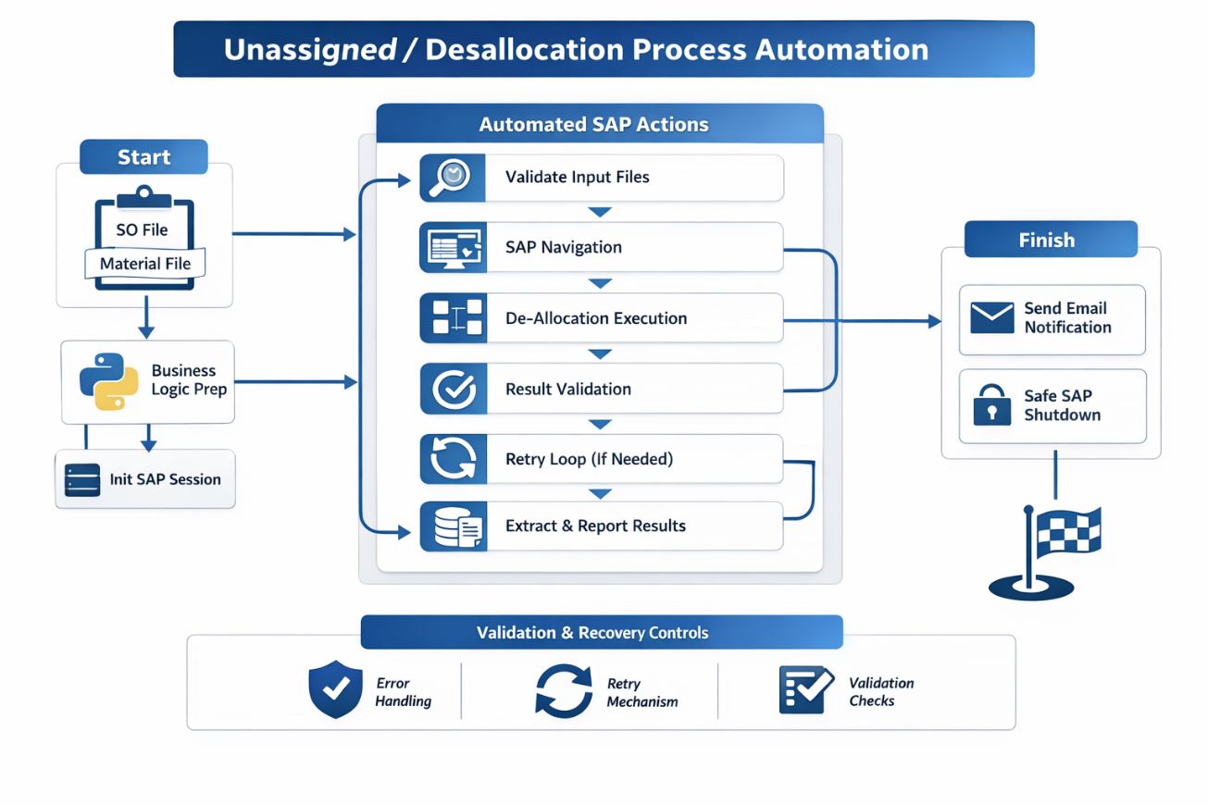

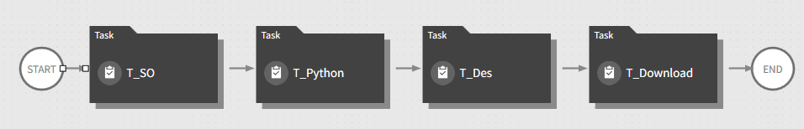

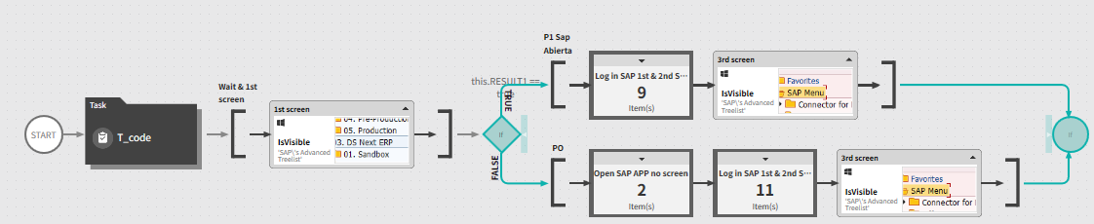
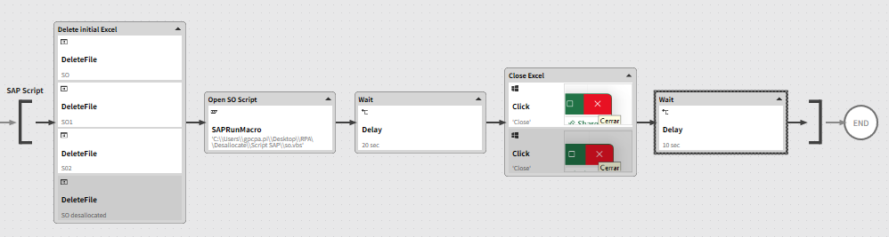
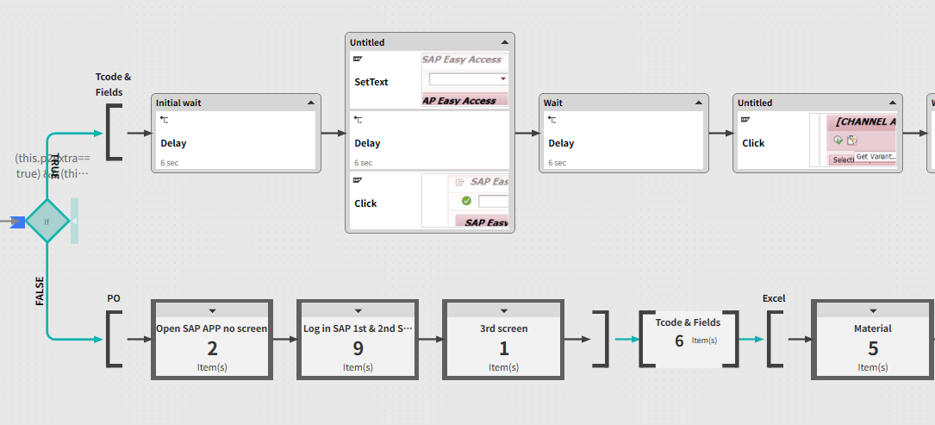

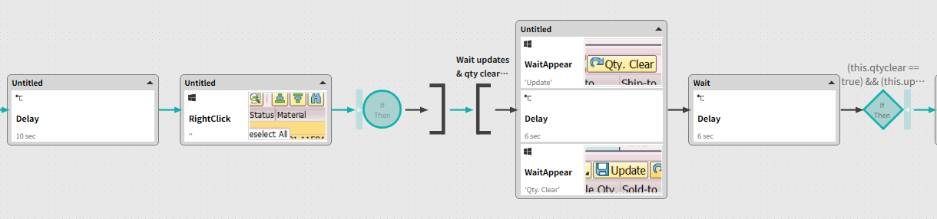

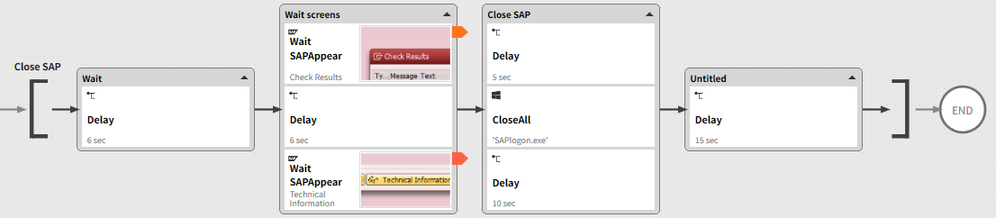

🚀 Executive Summary
Enterprise-grade RPA solution that automates an end-to-end SAP GUI Sales Order & Material de-allocation process, replacing a repetitive daily manual task with a resilient, validated, and fault-tolerant automation.
The solution integrates Python business logic, SAP GUI scripting, validation checkpoints, retry mechanisms, and automated reporting, delivering ~50 business days saved per year and eliminating operational risk.

🎯 Business Problem
The de-allocation process was executed manually on a daily basis and suffered from:
- High dependency on SAP session state
- Repetitive and time-consuming execution
- Risk of human error (wrong SOs or materials)
- No validation of execution results
- No visibility of time loss or efficiency impact
This generated inefficiency, rework, and risk in a productive SAP environment.

🧠 Solution Overview
A modular and resilient RPA architecture was designed to fully automate the process while separating business logic from SAP interaction.
Each critical step includes validation checkpoints, controlled retries, and error handling to ensure safe execution in SAP GUI.

🖼 RPA Orchestration Breakdown
High-level flow:
- SAP session initialization and cleanup
- Business logic preparation (Python)
- Input file validation (SO & Material files)
- SAP navigation with screen/state validation
- De-allocation execution
- Result validation (success / failure)
- Controlled retry loop (if required)
- Results extraction
- Automated email notification
- Safe SAP shutdown

📊 Results & Business Impact
- ~50 business days saved per year
- 100% elimination of manual execution
- Zero dependency on human availability
- Reduced operational risk in SAP
- Traceable execution and auditability

🔍 Before vs After
Before
- Manual daily execution
- High error probability
- No execution validation
- No performance metrics
After
- Fully automated process
- Validated execution at each step
- Automated reporting
- Measurable efficiency gains

🧩 Key Features
- Modular architecture
- SAP GUI state validation
- Retry & recovery mechanisms
- Dynamic file handling
- Automated email reporting
- Production-safe execution logic

🛠 Tech Stack
- Python (business logic, validation, reporting)
- SAP GUI Scripting
- RPA Orchestrator (enterprise environment)
- Excel (input/output files)
- Email automation (status & results)

🧠 Challenges & Design Decisions
- SAP instability → Solved with session cleanup and state validation
- Risk of partial execution → Implemented checkpoints and retries
- Tight coupling risk → Business logic fully decoupled from SAP layer
- Production safety → Conservative navigation and validations

👤 My Role
- RPA Solution Architect
- Python automation development
- SAP GUI scripting design
- Process architecture & validation strategy
- Error handling and resiliency design

🚀 Why This Project Matters
This project demonstrates how enterprise RPA, when designed correctly, is not just task automation but process engineering:
reducing risk, improving reliability, and delivering measurable business value in critical SAP operations.

